OCTOBER 2020 FORSYTH PUBLIC SCHOOLS MENU

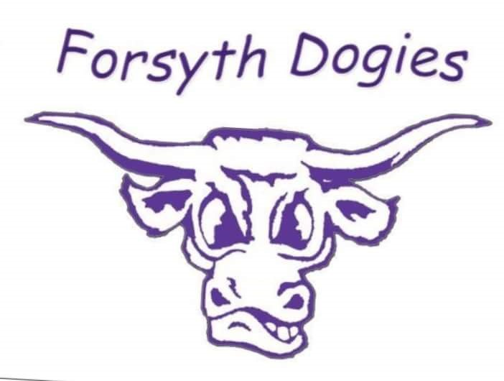
BREAKFAST PRICES LUNCH PRICES
K-12 $1.25 K-6 $2.25
Reduced $0.25 7-12 $2.50
Adult $1.25 Reduced $0.40
Adult $3.75

MONDAY | TUESDAY | WEDNESDAY | THURSDAY | FRIDAY
Note:  Juice or milk served with all breakfasts.  Fruit, vegetable and milk served with all lunches. | *MENU SUBJECT TO CHANGE |  | 1  Pop Tart  Cheese Stick  Chicken Alfredo Casserole  Breadstick | 2  Hard Boiled Egg  Crackers  Pizza Pretzel  Salad
5  Graham Cracker  Peanut Butter  Turkey Sandwich  Chicken Noodle Soup | 6  Breakfast Cookie  Fruit  Tater Tot Casserole  Dinner Roll | 7  Cold Cereal  Banana  Pancake Breakfast  Sausage Links | 8  Granola Bar  Juice  Roast Pork Gravy  Mashed Potatoes | 9  Muffin  Fruit  Fish Sticks  Potato Wedges
12  Yogurt  Fruit  Chicken Nuggets  French Fries | 13  Pop Tart  Fruit  Taco Spaghetti  Breadstick | 14  Turkey Cheese Rollup  Juice  Cheeseburger  Tater Tots | 15  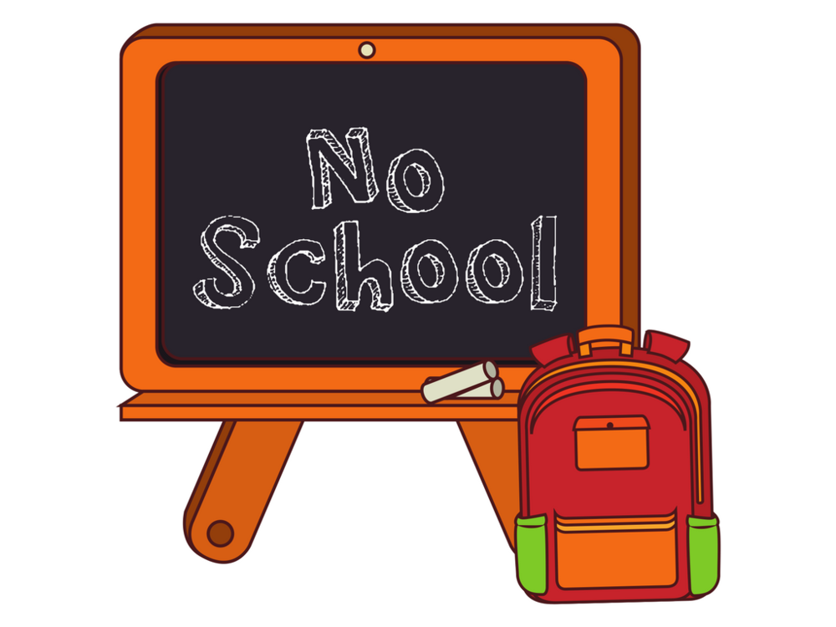 | 16
19  Cheez It Crackers  Hard Boiled Egg  Orange Chicken  Oriental Rice | 20  Granola Bar  Fruit  Beef Burrito  Dessert | 21  Yogurt  Fruit  Pulled Pork  Vegetable | 22  Muffin  Fruit  Meatballs  Mashed Potatoes/Gravy | 23  Cold Cereal  Banana  Ham  Scalloped Potatoes
26  Pop Tart  Juice  French Toast  Sausage Patty | 27  Little John Donut  Fruit  Nachos w/BBQ pork  Fruit | 28  Graham Crackers  Peanut Butter  Goulash  Garlic Bread | 29  Breakfast Cookie  Fruit  Birthday Meal  Corn Dog  Brownie & Ice Cream | 30  Muffin  Cheese Stick  Halloween Chicken Nuggets  Tater Tots

