NOVEMBER 2020 FORSYTH PUBLIC SCHOOLS MENU

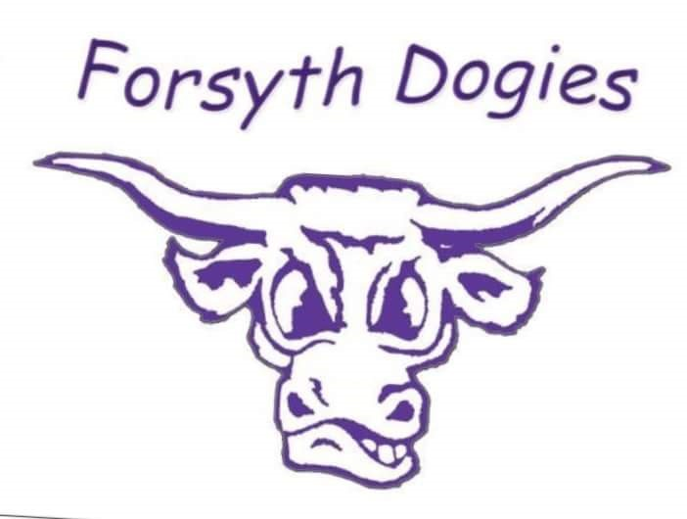
BREAKFAST PRICES LUNCH PRICES
No Charge for enrolled students No Charge for enrolled students
Adult $1.25 Adult $3.75

MONDAY | TUESDAY | WEDNESDAY | THURSDAY | FRIDAY
2  Yogurt  Fruit  Chicken Fried Steak  Mashed Potatoes w/ Gravy  Dinner Roll | 3  Nutri Grain Bar  Fruit  Taco Salad  Fruit  Churro | 4  Cinnamon Roll  Fruit  Hot Dog  French Fries  Cookie | 5  Pop Tart  Cheese Stick  Spaghetti  Breadstick  Fruit | 6
9  Graham Cracker w/ Peanut Butter/Fruit  Cheeseburgers  Potato Wedges | 10  Breakfast Cookie  Fruit  Soft Shell Tacos  Fruit | 11  Cold Cereal  Fruit  Breakfast Sandwich  Hash Browns | 12  Granola Bar  Fruit  Cheese Ravioli  Breadstick | 13  Muffin  Fruit  Tomato Soup  Grilled Cheese Sandwich
16  Yogurt  Fruit  Pancake Breakfast  Sausage Links | 17  Pop Tart  Fruit  Nacho Supreme  Fruit | 18  Gold Fish  Fruit  Chicken Nuggets  Tater Tots | 19  Cinnamon Roll  Fruit  Chili  Cornbread | 20  Meat/Cheese Wrap  Fruit  Thanksgiving Dinner
23  Chez It’s Crackers  Fruit  Spaghetti w/ Meatballs  Roll and Cookie | 24  Cold Cereal  Fruit  Taco Soup  Mini Tacos  Pudding | 25  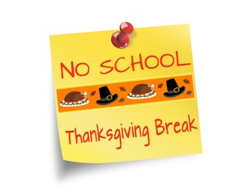 | 26  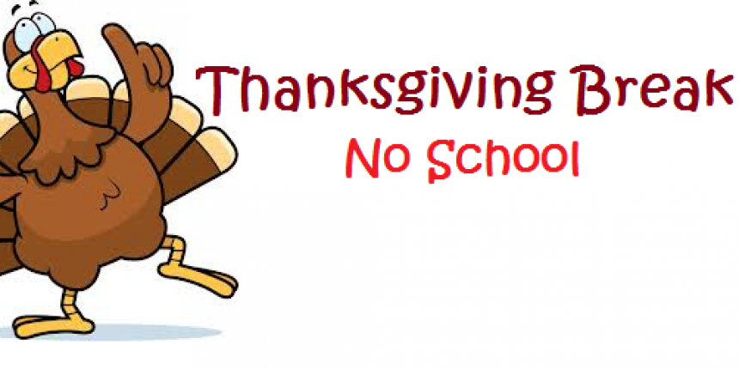 | 27
30  Pop Tart  Fruit  Birthday Meal  Corn Dog  Brownie/Ice Cream |  |  |  | Note:  Juice or milk served with all breakfasts.  Fruit, vegetable and milk served with all lunches.

