DECEMBER 2020 FORSYTH PUBLIC SCHOOLS MENU

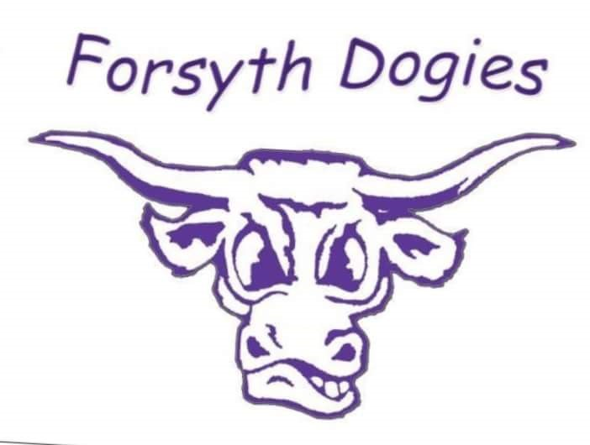
BREAKFAST PRICES LUNCH PRICES
No charge for enrolled students No charge for enrolled students
Adult $1.25 Adult $3.75

MONDAY | TUESDAY | WEDNESDAY | THURSDAY | FRIDAY
Note:  Juice or milk served with all breakfasts.  Fruit, vegetable and milk served with all lunches. | 1  Pop Tart  Fruit  Taco Noodle Casserole  Fruit | 2  Apple Cookie  Fruit  Lil’ Smokie  Mac and Cheese | 3  Granola Bar  Fruit  Hamburger Gravy  Mashed Potatoes | 4  Cold Cereal  Fruit  Pizza  Bell Pepper Sticks
7  Mini Bagel  Fruit  Sloppy Joes  Potato Salad | 8  Donut  Fruit  Burritos  Refried Beans  Spanish Rice | 9  Graham Cracker  Peanut Butter  Ham & Bacon Cheesy Potatoes  Peas | 10  Nutri-Grain Bar  Fruit  Chicken Drummies  Potato Cubes  Coleslaw | 11  Cold Cereal  Fruit  Beef Sliders  Side Winders
14  Granola Bar  Fruit  Cheeseburgers  Fries | 15  Uncrustable  Fruit  Walking Tacos  Carrot Sticks | 16  Go Gurt  Fruit  Chili  Cinnamon Roll | 17  Muffin  Fruit  Christmas Dinner  Ham  Mashed Potatoes | 18  Cold Cereal  Fruit  Pork Fritter Sandwich  Baked Beans
21  Nutri Grain Bar  Fruit  Chicken Strips  Gems | 22  Chocolate Chip Waffle  Fruit  Birthday Meal  Corn Dog  Brownie/Ice Cream | 23  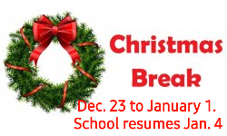 | 24 | 25
28 | 29 | 30 | 31

