JANUARY 2021 FORSYTH PUBLIC SCHOOLS MENU

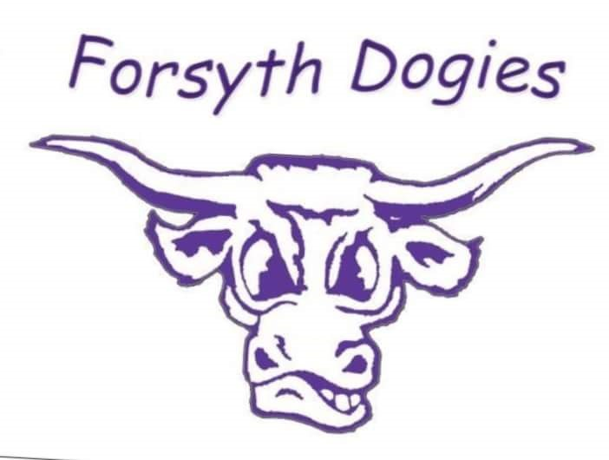
BREAKFAST PRICES LUNCH PRICES
No charge for enrolled students No charge for enrolled students
Adult $1.25 Adult $3.75

MONDAY | TUESDAY | WEDNESDAY | THURSDAY | FRIDAY
Note:  Juice or milk served with all breakfasts.  Fruit, vegetable and milk served with all lunches. |  |  |  | 1
4  Banana Bread  Fruit  Chicken Patty Sandwich  French Fries | 5  Granola Bar  Fruit  Soft Shell Tacos  Refried Beans | 6  Pop Tart  Fruit  Pizza  Fruit | 7  Cinnamon Roll  Fruit  Tater Tot Casserole  Vegetable | 8  Cold Cereal  Fruit  Meatball Sub Sandwich  Pasta Salad
11  Graham Crackers  Fruit  Breakfast Sandwich  Hash Brown | 12  UBR Granola  Fruit  Nacho Supreme  Fruit | 13  Cinnamon Bites  Fruit  Baked Chicken Wings  Fruit | 14  Go Gurt  Fruit  Spaghetti  Garlic Toast | 15  Cold Cereal  Fruit  Hot Dog  Baked Beans
18  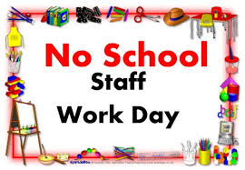 | 19  Pop Tart  Fruit  Fajitas  Fruit | 20  Apple Cookie  Fruit  Grilled Cheese  Tomato Soup | 21  Cinnamon Twist  Fruit  Turkey Gravy  Mashed Potatoes | 22  Cold Cereal  Fruit  Pizza  Fruit
25  Mini Bagel  Fruit  Raviolis  Breadstick | 26  Donut  Fruit  Chicken Enchiladas  Spanish Rice | 27  Nutri-Grain Bar  Fruit  Scalloped Potatoes  with Ham  Fruit | 28  Croissant  Fruit  Chicken Drummies  Potato Cubes | 29  Cold Cereal  Fruit  Birthday Meal  Corn Dog  Chips  Brownie/Ice Cream

