FEBRUARY 2021 FORSYTH PUBLIC SCHOOLS MENU

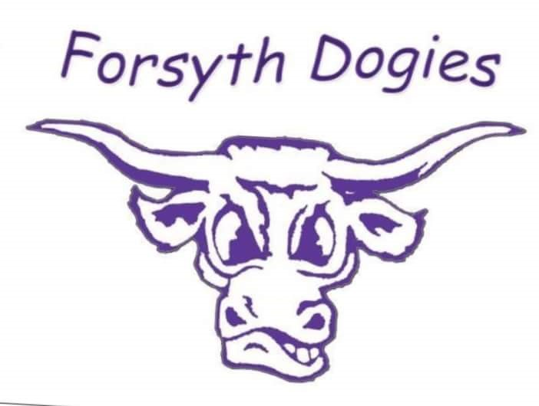
BREAKFAST PRICES LUNCH PRICES
No charge for enrolled students No charge for enrolled students
Adult $1.25 Adult $3.75

MONDAY | TUESDAY | WEDNESDAY | THURSDAY | FRIDAY
1  Granola Bar  Fruit  Pulled Pork Sandwich  Fruit/Veggie | 2  Uncrustable  Fruit  Chicken Quesadilla  Fruit/Veggie | 3  Yogurt  Fruit  Chili  Cinnamon Roll | 4  Muffin  Fruit  Barber Poles  Fruit/Veggie | 5  Cold Cereal  Fruit  Pork Fritter  Fruit/Veggie
8  Nutri-Grain Bar  Fruit  Cheeseburger  Fries | 9  Cinnamon Mini Bagel  Fruit  Indian Tacos  Fruit/Veggie | 10  Pop Tart  Fruit  Chicken Alfredo  Fruit/Veggie | 11  Chocolate Chip Waffle  Fruit  Sloppy Joes  Fruit/Veggie | 12  Cold Cereal  Fruit  Little Smokies  Mac & Cheese
15  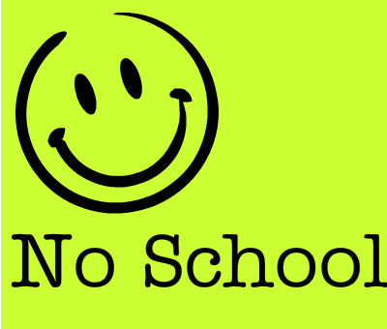 | 16  Cinnamon Bites  Fruit  Soft Shell Tacos  Fruit/Veggie | 17  Granola Bar  Fruit  Pizza  Fruit/Veggie | 18  Cinnamon Roll  Fruit  Shepherds Pie  Fruit/Veggie | 19  Cold Cereal  Fruit  French Dip  Fruit/Veggie
22  Apple Strudel  Fruit  Chicken Pot Pie  Fruit/Veggie | 23  UBR Granola Cookie  Fruit  Walking Taco  Fruit/Veggie | 24  Raspberry Scone  Fruit  Chicken Wings  Fruit/Veggie | 25  Yogurt  Fruit/Milk  Goulash  Breadstick | 26  Cold Cereal  Fruit  Birthday Meal  Corn Dog  Chips  Brownie/Ice Cream
Note:
Juice or milk served with all breakfasts.

Fruit, vegetable and milk served with all lunches.

